Beef Cattle Memory Game

Directions: Print these pages off on a color printer. Cut the cards around the outline. Laminate the 22 cards to make a set of matching memory cards. Students can match the words to the correct picture. This activity will enhance student’s vocabulary and help them associate vocabulary with pictures. Pictures may also be enlarged for creative uses.

Dairy Cow Calf

Bull Rumen

Pasture Beef Cow

Corn Hay

Veterinarian Beef

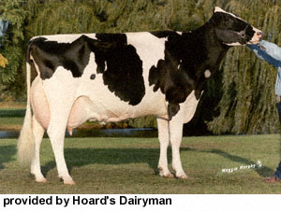

Nursing Calf

