Ground Beef
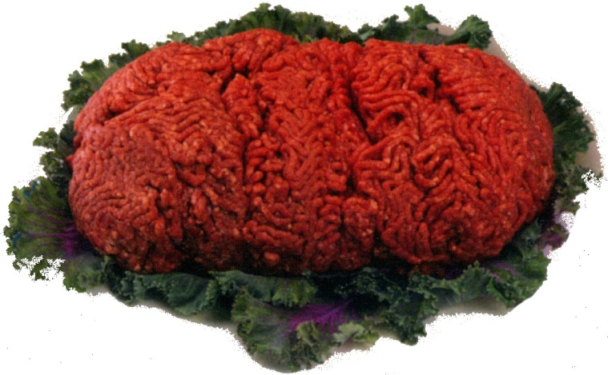
Taste Test Lessons

Two lab experiments for Middle School/High School, Food Prep and Culinary

Experiment 1 – compare beef patties from different percentage-lean
ground beef for tenderness, juiciness, flavor and cost per
serving.

Experiment 2 – compare ground beef crumbles made from different
percentage-lean ground beef for tenderness, juiciness,
flavor and cost per serving.

This lab-based ground beef lesson incorporates Iowa Core Health Literacy and Family and Consumer Sciences National Standards, while utilizing the inquiry-based lab method of Science Writing Heuristic to encourage high rigor and high relevance.
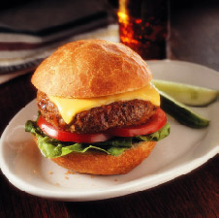
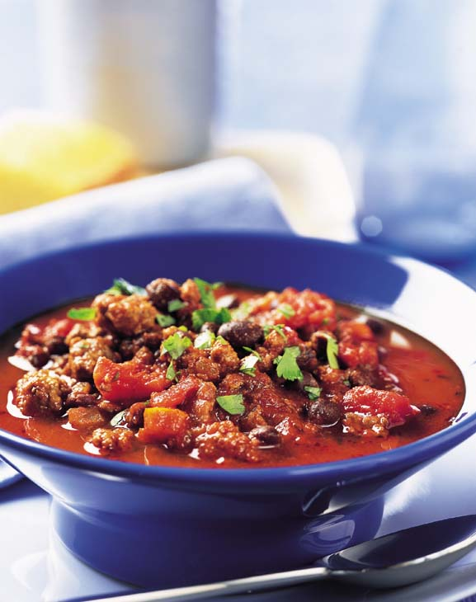
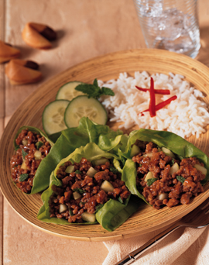
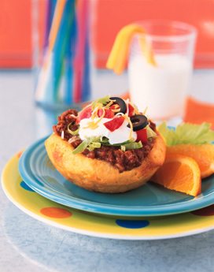

Lesson developed by Nancy Degner, Iowa Beef Industry Council and Kristie Kuhse, Waverly-Shell Rock Middle School, FCS teacher.
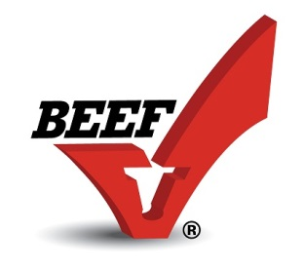

Iowa Beef Industry Council www.iabeef.org 515-296-2305 beef@iabeef.org
Ground Beef Taste Tests
Age level: Middle School - High School; Food Prep and Culinary

Standards:
Iowa Core Health Literacy Standard: Demonstrate functional health literacy skills to obtain, interpret, understand and use basic health concepts to enhance personal, family and community health.
Family and Consumer Sciences Standard XIV: Demonstrate nutrition and wellness practices that enhance individual and family well-being.

Benchmarks:
- Evaluate factors that affect food safety, from production through consumption.
- Evaluate the impact of science and technology on food composition, safety, and other issues.

Objectives:
- Students will describe the factors which influence the palatability of ground beef products related to tenderness, juiciness and flavor.
- Students will be able to explain how the fat content of ground beef influences color, taste and cost.
- Students will prepare an extra lean ground beef patty with a modification for tenderness and flavor.
- Students will participate in a taste panel.

Background:
More than 50% of all beef sold in the U.S. today is ground beef. Ground beef is economical, versatile and can be used in hundreds of ways. Consumers may be confused by the different types of ground beef available at the meat case; this lesson will help students select the ground beef for a specific use.

Generalizations:
- Ground beef is pure, 100% beef with some fat present. No fillers, cereal products or additives may be used unless specified on the label.
- Ground beef options vary according to %-lean content found on the label. 85% lean / 15% fat means 85% of the weight is lean muscle and 15% is fat.
- By law, ground beef can contain no more than 30% fat.
- Fat content of ground beef will affect the flavor, juiciness and tenderness of beef patties. Consumer research shows that the most preferred beef patties are 80 to 85% lean for flavor and juiciness. As fat content decreases, the beef will become drier.
- Fat content will affect shrinkage; leaner ground beef will lose moisture while a higher fat content will lose fat through preparation.
- Ground beef may carry the label “ground round” or “ground chuck” indicating the section of the beef carcass it came from. However by law, ground beef must be labeled with % lean/% fat.

- Different %-lean ground beef products may be used in different recipes.
  - Ground beef less than 80%-lean is good for dishes in which you drain the fat from the cooked beef, such as Sloppy Joes, chili and spaghetti sauce.
  - Ground beef 80-85% lean is good for meat loaf / meatballs / beef patties as they hold their shape better when a moderate level of leanness is used. Beef patties with this level of fat are juicier.
  - Ground beef 90-96% lean is good for combination dishes where the beef is not cooked first and low calorie recipes. Extra lean ground beef may crumble, fall apart and be drier in a patty.
  - Any type of ground beef may be used to make ground beef crumbles, although the less expensive types may offer a better value.
- Extra lean ground beef patties can be made more tender and juicy by adding an egg white and bread crumbs. See directions in Ranch Burgers recipe.
- Ground beef with a higher percent of fat may be placed in a colander (after cooking) and rinsed to reduce fat. See Reducing Fat in Cooked Ground Beef.

References/Resources:
- Reducing Fat in Cooked Ground Beef
- Ground Beef Nutrient Comparisons – see page 2
- Burger Battle: Ground Beef vs. Ground Turkey
- Recommended Temperatures for Cooking Meat and Poultry – USDA
- Thermometer Placement & Temperatures – USDA
- Start your Engines with Ground Beef – PPT for middle school
- Ground Beef Lesson and Study Guide
Safety
- Color of Cooked Ground Beef as it Relates to Safety – USDA
- Ground Beef and Food Safety – USDA
- Lean Finely Textured Beef (Pink Slime) - www.beefisbeef.org See FAQ and Fact Sheets
- How Ground Beef is made - www.cargillgroundbeef.com

Recipes
- 100 Burger Ideas
- Easy Ground Beef Recipes

Just for Fun
- Hamburger Timeline
- Hamburger Trivia

Suggested Activities:
Experiment 1 – Ground Beef Patty Taste Test – compares the types of ground beef used to make a beef patty. The Experiment will utilize the (SWH) Science Writing Heuristic Method, proper food safety and food preparation skills. Each lab group will prepare four equal sized patties for the class to taste test. Patties will be weighed before and after cooking. Observations will be documented on the student worksheet.
Students will use an instant-read meat thermometer to measure internal doneness of the patty – 160 degrees F. Directions for the instant-read thermometer must be followed as usage varies according to type. See Thermometer Placement & Temperatures – USDA.
Purchase preference depends on the end use of the product (recipe). The highest price ground beef does not necessarily mean the ground beef will taste best. Buy ground beef according to intended use.
Experiment 2 – Ground Beef Crumbles Test – compares different types of ground beef used to make beef crumbles. The Experiment will utilize the (SWH) Science Writing Heuristic Method, proper food safety and food preparation skills. Students will prepare ground beef crumbles made from different percent-lean ground beef in a skillet. They will weigh before and after cooking, and compare flavor, shrinkage/drippings/cost per serving including an option to rinse the cooked crumbles from a higher fat ground beef. Observations will be documented on the student worksheet.
Purchase preference depends on the end use of the product (recipe). The highest price ground beef does not necessarily mean the ground beef is the best choice for crumbles. Buy ground beef according to intended use.
Other Ideas:
Compare the taste of ground beef, ground lamb, ground turkey and ground chicken patties. Be sure to keep the leanness of the meats the same. See Ground Beef Nutrient Comparisons and Burger Battle: Ground Beef vs. Ground Turkey for additional information.

Experiment 1 – Ground Beef Patty Taste Test
Materials needed:
- 1 pound each of 80%, 85%, 90%-lean ground beef (for smaller class, use 80% and 93%)
- 2 pounds of 93-96% lean ground beef
- one egg white
- ¼ cup soft bread crumbs
- 1 tsp. seasoned salt
- 5 skillets (at least 2 should be non-stick)
- 5 knives
- 5 spatulas
- 5 – 1 cup glass measuring cups or small clear plastic cups
- Instant read thermometer
- Scale (check the chemistry department?)
- Waxed paper or plastic wrap to place on scale
- Small paper tasting plates, markers to identify products
- Ranch Burger Recipe – for the 96% lean ground beef patty
- Compare the Difference sheet for each student

1. Exploration of Pre-instruction Understanding
- Discuss proper food safety handling of ground beef – wash hands with hot soapy water before and after handling the raw meat to prevent food borne illness.
- Ground Beef needs to be cooked to 160 degrees Fahrenheit. Use a meat thermometer to check temperature.
- Beef patties should be cooked the same length of time and be tasted at the same temperature so the cooking among groups should be coordinated.
- Students will prepare the ground beef patties in their lab group and deliver the product to a central location for others to sample.
- Discuss a taste panel – used to collect data, compare products, analyze cooking methods, etc.
- Students will place one bite of each sample on their plates, sit down and carefully taste each sample.
- Students should NOT compare findings with neighbors until the experiment is completed.
- Students will complete the Compare the Difference worksheet.

2. Pre-Lab Activities
- Divide students into 5 groups for this experiment.
- Each student will mark a paper plate into 5 sections and label – A, B, C, D and E.
- Identify each of the 5 types of ground beef with – A, B, C, D and E and determine which lab group will be preparing which type of ground beef.
- Discuss appearance of the raw meat as to color and amount of fat present (the leaner the ground beef, the more red the color.)
3. Participation in Lab Activity
- Each group will make 4 equal sized patties – ½ inch thick - out of each pound of ground beef.
- **One group will add 1 egg white, ¼ cup of soft bread crumbs and 1 teaspoon seasoning salt to their one pound of 93-96% lean ground beef and mix lightly. ** Refer to Ranch Burger Recipe
- Weigh each patty before and after cooking. Record data on Compare the Difference Worksheet.
- Place a small hole or indentation in each patty to speed cooking.
- Pre-heat skillets to medium; place patties in the skillet and cook about the same amount of time, turning with a spatula.
- DO NOT press down on patties while cooking. Leaner patties may cook more quickly. Patties should reach 160 degrees F, as measured with an instant-read thermometer inserted horizontally.
- Reweigh patties using scale. Record data on Compare the Difference Worksheet.
- Pour off drippings into measuring cups or small plastic containers for comparison.
- Place each group of patties on a plate identified with its letter and cut into bite-sized pieces.
- Each student will take a piece of each of the five Taste Test patty samples.
- Each student will record data and observations on Compare the Difference Worksheet.
- Clean up lab area.

4. Negotiation Phase 1 – Write personal meanings
- Students will use data collected on the five different types of ground beef considering the % lean, weight raw and cooked, cost per pound and flavor to make claims based on the observations and evidence gathered.
- Example: “I can claim that the fat content will affect the flavor, juiciness and tenderness of the beef patty. As the % lean increased, the beef became drier.”
- What regulations are in place in the beef and meat industry to ensure food safety and quality?
- Suggested resources: www.beefisbeef.org and www.cargillgroundbeef.com and USDA – Ground Beef and Food Safety.
5. Negotiation Phase II – Share data with the other groups
- Students compare their findings with the other groups by writing their statements on the whiteboard or butcher paper. Groups share their claims and generalizations that can be made from the experiment.
6. Negotiation Phase III- Compare findings to scientific community and experts
- Students will compare claims to the online and text resources listed in the Resource section of the lesson plan. The Generalizations listed in the lesson plan would also be helpful information for students.
7. Negotiation Phase IV – Individual reflection
- Students reflect on their results and discuss how their ideas have changed from the lab experiment.
- Students expand on their finding about the meat industry and regulations to ensure safe and quality meats are sold. (suggested reflection: pink slime, how ground beef is made)
- Students write their opinions of the experience – positive and negative including the amount of drippings poured off of each type – if any, the best flavor, juiciest, and most tender. Students should consider shrinkage, cost per serving and which is the best %-lean for hamburger patties?
8. Discuss student reflections and check for understanding. Ground beef is economical, versatile and can be used in hundreds of ways. Ground beef should be selected for the specific use. Burgers, casseroles and other dishes yield the best product depending on the choice of lean meat. What is the best choice for people wishing to reduce the fat content in their diet?
Experiment 2 – Ground Beef Crumbles Test
Students may taste each sample if desired (or save the crumbles for later lab with ground beef).
Materials Needed:
- 1 pound each of 80%, 85%, 90% and 93-96% lean ground beef
- Option – extra pound of 80% to brown, crumble and rinse
- 1 skillet and spoon for each pound of ground beef
- Scale (check the chemistry department?)
- Paper plates to weigh ground beef crumbles
- 1 glass (1-cup) measuring cup or clear plastic cup per pound of ground beef
- Compare the Difference Worksheet for each student

1. Exploration of Pre-instruction Understanding
- Discuss proper food safety handling of ground beef – wash hands with hot soapy water before and after handling the raw meat to prevent foodborne illness.
- Discuss a taste panel – used to collect data, compare products, cooking methods, etc.
- Students will prepare the ground beef crumbles in their lab group and deliver the product to a central location for others to sample.
- Students will place one bite of each sample on their plates, sit down and carefully taste each sample.
- Students should NOT compare findings with neighbors until the experiment is completed.
- Students will complete the Compare the Difference worksheet.

2. Pre-Lab Activities
- Divide students into 5 groups for this experiment.
- Each student will mark a paper plate into 5 sections and label – A, B, C, D and E.
- Identify each of the 5 types of ground beef with – A, B, C, D and E and determine which lab group will be preparing which type of ground beef.
- Discuss appearance of the raw meat as to color and amount of fat present (the leaner the ground beef, the redder the color.)
- Divide students into groups for this experiment. Use the leftover ground beef crumbles for a lab for recipes made with ground beef crumbles.

3. Participation in Lab Activity
- Each group should weight their “pound” of ground beef so it is exactly 16 ounces. Record on Compare the Difference Worksheet.
- Heat skillet to medium and brown ground beef, breaking up crumbles while stirring. Break crumbles to ¾-inch in size (some consistent level). Be careful with the 90-96% lean as it can get dry and burn.
- Carefully pour off all drippings into measuring cup/container and mark with letter of ground beef.
- Weigh ground beef crumbles and record.
- Have each group determine the cost per cooked ounce of ground beef by dividing the weight of the cooked meat into the cost per pound of the raw ground beef. Record data on Compare the Difference Worksheet.

Option – use directions from Reducing Fat in Ground Beef to rinse 80%-lean crumbles and compare weight, calories, costs and taste.
4. Negotiation Phase 1 – Write personal meanings
- Describe personal observations during the lab. Record on Compare the Difference worksheet. Students will make claims based on evidence gathered in the lab.
- Students will use data collected on the five different types of ground beef considering the % lean, weight raw and cooked, cost per pound and flavor to make claims based on the observations and evidence gathered.
- Example: “I can claim that the fat content will affect the flavor, juiciness and tenderness of the beef patty. As the % lean increased, the beef became drier.”
- What regulations are in place in the beef and meat industry to ensure food safety and quality?
- Suggested resources: www.beefisbeef.org and www.cargillgroundbeef.com
5. Negotiation Phase II – Share data with the other groups
- Students compare their findings with the other groups by writing their statements on the whiteboard or butcher paper. Groups share their claims and generalizations that can be made from the experiment.
6. Negotiation Phase III- compare findings to scientific community and experts
- Students will compare claims to the online and text resources listed in the Resource section of the lesson plan. The Generalizations listed in the lesson plan would also be helpful information for students.
7. Negotiation Phase IV – Individual reflection
- Students write their opinions of the experience – positive and negative including the amount of drippings poured off of each type – if any, the best flavor, juiciest, and most tender. Students should consider shrinkage and cost per serving.
- Students write the best explanation based on what they learned from this laboratory experience.
- Students expand on their finding about the meat industry and regulations to ensure safe and quality meats are sold. (suggested reflection: pink slime, how ground beef is made)
8. Discuss student reflections and check for understanding
Which is the best ground beef for a hamburger patty? For ground beef crumbles? For low cost? For health and reducing fat content in the diet? Ground Beef may be purchased in bulk and crumbles can be prepared and frozen for future use. This can be an economical way for consumer to save money and time with food preparation.

Types of Ground Beef – compare % lean

Sample | %- lean ground beef | Weight-raw | Weight-cooked | Cost/ pound | Cost / ounce | Flavor / Comments

Which ground beef lost the most weight?__________________________________________________

Which ground beef cost the least per ounce? _______________________________________________

Which ground beef cost the most per pound?_______________________________________________

Which ground beef has the best flavor?____________________________________________________

Which is the best choice for health and reduced fat content? ___________________________________

What did I do? What were my procedures? | Observations: What did I find? What were differences between the samples?
My Claim is: | My evidence is:

What do others say:
Internal Experts: | External Experts:
Reflection: How have my ideas changed? What is the best ground beef to buy?

Ranch Burgers
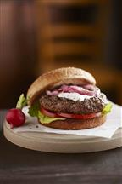
Makes 4 servings

INGREDIENTS
1 pound ground beef (96% lean)*
1/4 cup soft bread crumbs
1 egg white
1 teaspoon seasoned salt
1 medium red onion, cut crosswise into 1/2-inch thick slices
1 tablespoon vegetable oil, divided
4 whole wheat hamburger buns, split, toasted
Romaine lettuce, tomato slices
1/4 cup reduced-fat creamy ranch dressing

INSTRUCTIONS
- Combine ground beef, bread crumbs, egg white and seasoned salt in medium bowl, mixing lightly but thoroughly. Lightly shape ground beef into four 1/2-inch thick patties. Brush onion slices with 1/2 tablespoon oil.
- Place patties and onion slices on grid over medium, ash-covered coals. Grill patties, covered, 8 to 10 minutes (over medium heat on preheated gas grill, covered, 7 to 9 minutes), until instant-read thermometer inserted horizontally into center registers 160°F, turning occasionally. Grill onions, 11 to 13 minutes or until tender, brushing with remaining 1/2 tablespoon oil and turning occasionally.
- Line bottom of each bun with lettuce. Place tomatoes and burgers on lettuce. Spoon dressing over burgers; top with onions. Close sandwiches.

∗ Use 90 – 96% lean for this recipe.
- Cooking times are for fresh or thoroughly thawed ground beef. Color is not a reliable indicator of ground beef doneness.

NUTRITIONAL INFORMATION

Nutrition information per serving for 96% lean: 309 calories; 8 g fat (3 g saturated fat; 1 g monounsaturated fat); 67 mg cholesterol; 811 mg sodium; 32 g carbohydrate; 4.5 g fiber; 28 g protein; 8.3 mg niacin; 0.5 mg vitamin B₆; 2.1 mcg vitamin B₁₂; 4.1 mg iron; 41.6 mcg selenium; 6.3 mg zinc; 95.6 mg choline.
This recipe is an excellent source of protein, niacin, vitamin B₆, vitamin B₁₂, iron, selenium and zinc; and a good source of fiber and choline.


References/Resources:

- Reducing Fat in Cooked Ground Beef - http://www.beefnutrition.org/cmdocs/beefnutrition/reducingfatincookedgroundbeef.pdf

- Ground Beef Nutrient Comparisons – see back page http://www.beefnutrition.org/cmdocs/beefnutrition/naturallynutrientrichleangroundbeef.pdf-

- Burger Battle: Ground Beef vs. Ground Turkey - http://www.beefnutrition.org/cmdocs/beefnutrition/gbvsgt_factsheet.pdf

- Recommended Temperatures for Cooking Meat and Poultry – USDA http://www.foodsafety.gov/blog/meat_temperatures.html

- Thermometer Placement & Temperatures – USDA
http://www.fsis.usda.gov/wps/portal/fsis/topics/food-safety-education/teach-others/fsis-educational- campaigns/is-it-done-yet/thermometer-placment-and-temperatures/CT_Index

- Start your Engines with Ground Beef – PowerPoint presentation on ground beef developed for middle school by Kristie Kuhse, Waverly-Shell Rock Middle School. http://www.iabeef.org/CMDocs/IowaBC/Start%20Your%20Engines%20with%20Ground%20Beef.ppt

- Ground beef lesson and Study Guide to accompany Start Your Engines with Ground Beef PPT
. http://www.iabeef.org/CMDocs/IowaBC/LessonPlan&StudyGuide.pdf

Safety
- Color of Cooked Ground Beef as it Relates to Safety – USDA
http://www.fsis.usda.gov/wps/portal/fsis/topics/food-safety-education/get-answers/food-safety-fact-sheets/meat-preparation/color-of-cooked-ground-beef-as-it-relates-to-doneness/ct_index

- Ground Beef and Food Safety – USDA http://www.fsis.usda.gov/wps/portal/fsis/topics/food-safety-education/get-answers/food-safety-fact-sheets/meat-preparation/ground-beef-and-food-safety/CT_Index

- The Facts on Lean Finely Textured Beef (Pink Slime) www.beefisbeef.com

- How Ground Beef is Made - www.cargillgroundbeef.com

Recipes
- 100 Burger Ideas - http://www.iabeef.org/CMDocs/IowaBC/100_BurgerIdeas.pdf
- Easy Ground Beef Recipes - http://www.iabeef.org/CMDocs/IowaBC/EasyGroundBeefRecipes.pdf

Just for Fun
- Hamburger Timeline - http://www.iabeef.org/CMDocs/IowaBC/HamburgerTimeline.pdf
- Hamburger Trivia - http://www.iabeef.org/CMDocs/IowaBC/HamburgerTrivia.pdf

