The Role of Cattle in the Miraculous Chain of Sun to Grass to Human Food.

Cattle production is really a study in efficient utilization of solar energy as well as a prime example of the incredible efficiencies of modern American agriculture.

The development and evolution of agricultural techniques and the application of modern technology have led to phenomenal gains in food productivity. America is unique in the world – less than 2% of the population feeds all of the nation’s population, produces substantial surpluses for export, and, at the same time, keeps food costs, as a percentage of disposable income, at the lowest level in the world.

The history of civilization and the development of modern agriculture include the evolution of ruminant (four –part stomach) animals as a major food source. Ruminant animals are unique because they can digest plant cell carbohydrates (cellulose), which humans can’t digest. Cattle, one of the ruminant species, have played a key role as energy converters and “nutrition reservoirs” in food production systems throughout the world.

Solar energy is basic to cattle production. The sun’s rays, striking millions of acres of pasture and range land, provide energy for grass and other forages to grow. Cattle then harvest this renewable resource, which would otherwise be of no food value to people, and convert it into flavorful, healthful food – beef. Beef is described by nutritionists as nutrient-dense, providing consumers with large amounts of their daily requirements for protein, vitamin B-12, iron, zinc and other essential nutrients.

At least 85% of the nutrients consumed by cattle come from grass, roughage, food processing by-products and other feedstuffs not edible by people. Of the 1.2 billion acres of agricultural land in the U.S., only one-third can be used for crop production. Utilization of the balance of this land for food production requires grazing by ruminant animals.

Grasslands and grazing livestock are naturally compatible. Ruminant animals, with their unique digestive system, evolved as consumers of grass and other leafy vegetation, and the plant life on our rangelands evolved under grazing by buffalo and other ruminant wildlife. Now, a good way to maintain and improve those grasslands, to the benefit of wildlife as well as livestock, is through scientific grazing management.

Solar energy is basic to cattle production…

Cattle are excellent natural recyclers of organic wastes from the production and processing of grains, fruits, vegetables, and other foods. Man can eat less than half the dry matter produced by crops. Most of the remaining roughage and other material are fed to cattle and other farm animals and thus do not present a disposal problem. Some 25% of all by-products from food processing are used as sources of protein and other nutrients for livestock.
Thus, it can be seen, cattle enhance man’s ability to feed a growing population. Without ruminants, the solar energy reaching the more than 800 million acres of range and pastureland would be of no food value to this country.

Cattle production isn’t just about solar energy use; it’s also about people, the farm and ranch families who oversee the incredible chain of sun to forage to cattle to food. The nation’s 1 million cattle producers own or manage more land in America than any other group. Cattle and calves are produced in more states and regions than any other farm commodity.

The cattle industry is the largest segment of agriculture, accounting for almost one-fourth of all farm marketings. The annual sales of $66 billion worth of cattle and calves are vital to thousands of rural communities, and those sales generate millions of jobs – from farm and ranches, to local stores, to processing plants, to supermarkets and restaurants.

Cattle production is a way of life as well as a business. The land sustains the cattle, and hence the cattleman and his family, is more than likely the same land that was owned and cared for by the cattleman’s father and grandfather. More than half of all cattle operations in the U.S. have been in the same family for more than 50 years, and more than 10% have been in the same family for more than 100 years.

Part of a cattleman’s legacy is a responsibility to care for the animals and resources which he inherits. His family’s livelihood, and the livelihoods of future generations, depends on it. Recognizing their obligation to be good stewards of the land, cattleman live by the saying, “We don’t inherit the land from our forefathers; we borrow it from our children.”

RUMINANTS RECYCLE AND CONSERVE

Cattle and other ruminants are nature’s models for food energy conservation. Ruminants have unique stomachs with four cavities that allow them to eat products that other animals find inedible.

Directions

Read the information below and then follow the path of food as it moves through the ruminant stomach by writing the step numbers in the boxes on the diagram below. Some of the numbers will be used more than once.

RUMINANT STOMACH

- Teeth tear and chew food in mouth
- Food travels down esophagus
- Cud (swallowed food) mixes and softens in stomachs 1 and 2
- Cud returns to mouth for more chewing by rear molars
- Cud passes through stomachs 1,2,3, and 4 as it is digested and nutrients absorbed
- Waste materials pass through intestines and exit body as manure

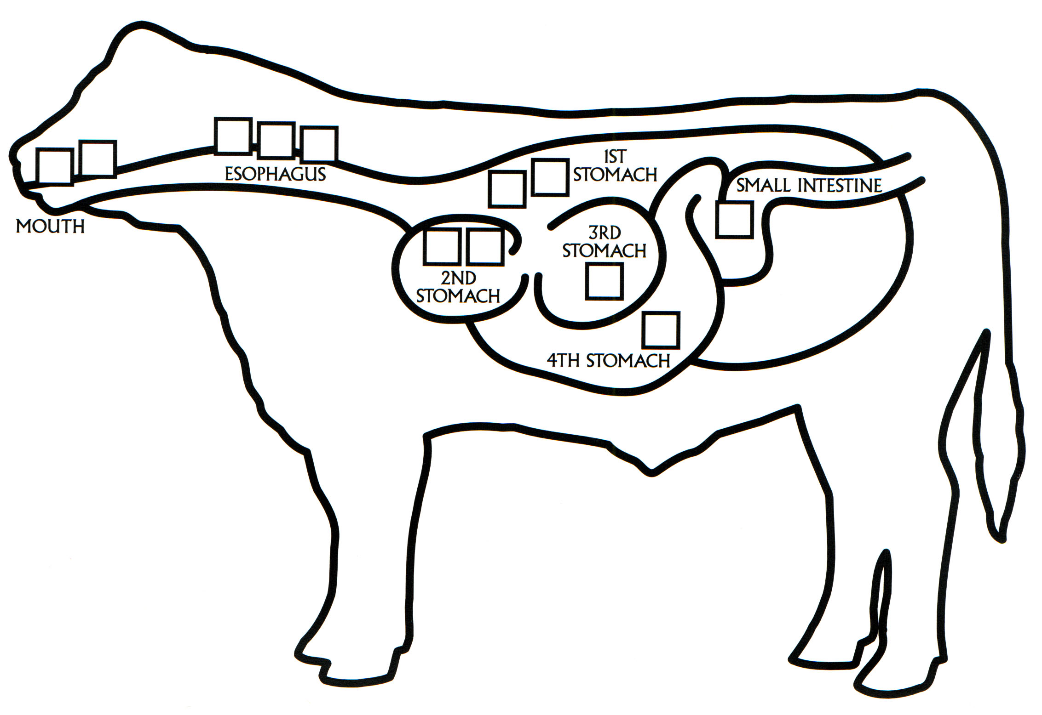

FIND OUT

1. What other animals are ruminants?
______________________________________________________________________________________________________________________________________________________________________________________________________________________________________________________________________________

MORE ABOUT RUMINANTS

Directions
Examine the information on this page and underline information that is new to you.

Almost half of the land in the United States is classified as pasture and range land. Most of that land cannot be used for farming or growing because it is to high, too rough, too dry, or too wet. Grass from these lands contains cellulose, which is indigestible by humans. Because they are ruminants, cattle can eat grasses and convert them to beef and dairy products that humans can eat.
Cattle producers are responsible for managing cattle and land in ways that will protect the environment. This is in the producers best interests, since caring for the land will allow the land to care for the cattle on which they depend.
About 85% of nutrients consumed by cattle
Cattle eat:
almond hulls
barley or hops hulls
cereal by-products
citrus pulp
corn and other grains
corn gluten
corn stalks
cotton seed husks
culled vegetables
grasses
molasses
potato peels
soy hulls
sugar beet pulp
shrubs
weeds

Products from cattle:
butter
cheese
hamburgers
hot dogs
ice cream
milk
roast beef
steaks
cosmetics
glue
leather: shoes, gloves, coats
some medicines
soap
sports equipment
pet foods
fertilizer
come from sources not suitable as food for
humans. Many beef cattle go from grazing
lands to feedlots. There they are fed
roughage and grains for about 100 days.
Feedlots help to keep supplies of beef
constant, making beef available year-round
and keeping prices stable. Cattle producers
also use their animals as recyclers by
feeding them food-processing by-products
that would otherwise be shipped to landfills.
More than half of the by-products of fruit,
vegetable and grain processing go into
livestock feed. Foods from cattle provide
high-quality protein, calcium, and vitamins
such as iron, zinc, and B-vitamins that
humans need to maintain a healthy diet.
Equally important are the other products
from cattle that humans use everyday.

PROCESSING INFORMATION
Explain in your own words how cattle are nature’s model for environmental conservation.

_________________________________________________________________________________________________
_________________________________________________________________________________________________
_________________________________________________________________________________________________

APPLICATION
List items you can conserve. Place a check mark next to those you currently conserve or recycle. Circle those items you plan to start conserving. Write an explanation next to those things you don’t plan to reuse, recycle, or reduce.

________________________________________________________________________________________________
________________________________________________________________________________________________
________________________________________________________________________________________________

